**Candidate Code – CC196**

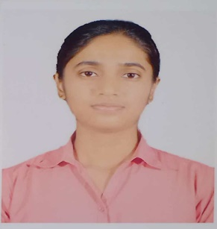

|  |  |  |  |  |
| --- | --- | --- | --- | --- |
| **ACADEMIC DETAILS** | | | | |
| **COURSE** | **SPECIALIZATION** | **INSTITUTE/COLLEGE** | **BOARD/UNIVERSITY** | **YEAR** |
| CLASS XII | SCIENCE | DAV Public School | CBSE | 2021 |
| CLASS X |  | DAV Public School | CBSE | 2019 |

|  |  |
| --- | --- |
| **Subjects/Electives** | Python programming, C programming, Data Structures and Algorithms, Data Communication and Computer Networks, Object Oriented programming in C++, Switching Circuits and Logic Design, Machine learning, Object Oriented programming in Java, Theory of Computation, Operating System, Database Engineering, Computer Organisation and Architecture, Discrete Mathematics, Engineering Mathematics, Software Engineering and Agile Methodology, Internet of Things, Enterprise Java, Cloud Computing |
| **Technical Proficiency** | C++, C, Java, Python, HTML, CSS, Bootstrap, JavaScript, AWS, React.js |

|  |
| --- |
| **SUMMER INTERNSHIP / WORK EXPERIENCE** |
| **Summer Research Intern May 2024 – July 2024**  ***Project :******Grad-CAM based Defect Detection Model for Structural Health Monitoring***   * Developed and trained CNN architectures to detect structural cracks, achieving an accuracy of 92.90% with a pre-trained VGG16 model and utilizing Grad-CAM for improved object localization in detecting minor cracks.   **Vocational Training Intern, Tata Iron & Steel Company June 2023 – June 2023**  ***Project: KPI Monitoring***   * Created a UI for KPI monitoring which showcased different objectives of the copany along with their strategies and sub-strategies using HTML, CSS, JavaScript(Mermaid JS). * Learnt about database creation. |

|  |
| --- |
| **PROJECTS** |
|  |

|  |
| --- |
| **POSITION OF RESPONSIBILITY** |
|  |

|  |
| --- |
| **EXTRACURRICULAR ACTIVITIES** |
|  |

|  |
| --- |
| **CERTIFICATIONS** |
|  |